Name: Zobia Khalid Roll #3355  
Project: Timetable Submitted to: Sir Farukh Bashir

**Methods:**

Project is created on ASP.NET MVC Core. Used scaffolding. CRUD Operation are performed.  
For Login data is retrieved from database and after comparing data entered with database data it redirects to desired page. Main page is Login page project first redirect to Login controller, Index View.

Used session for login user. And displays login user name.

After Login if wants to logout page redirect again to login page. And session ends

2 Timetable Pages:

1 that View Manual Timetable using Html and CSS and Some mix-up of Strongly type Html helpers.

Other one is the page that retrieve data direct from database. With searching button on it for easiness for user in searching desire course.

Used Foreign Keys for relationship between tables for example courses with semester etc.  
**Tools:**

MSSQL, Visual Studio,

**Languages:**  
C#, Html, Bootstrap, CSS, JS,SQL

**Purpose:**

In this Project a student can search for courses. Their prerequisites and credit hours. He/She can follow the semester plain or can enter his own semester plain for himself and also can for other students as suggestion to follow, if they don’t want to follow the university plain.  
Through Search button they can check timetable of their course and can decide their course on timetable. If can feel there is clash, they can remove their clash by self and coordinator do not have to change the timetable again and again, because students can help their oneself.

Tables:

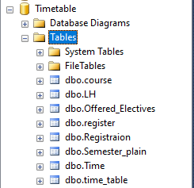

Controllers:

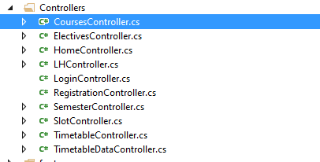

Views:

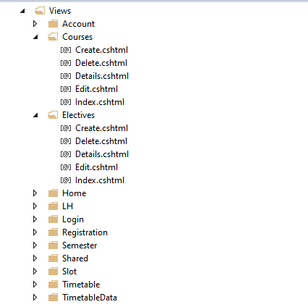

Models:

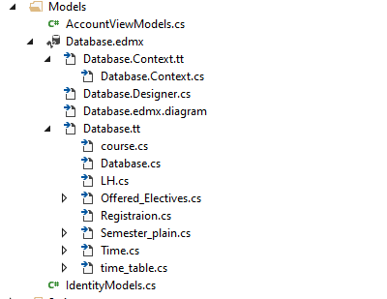

1. Courses

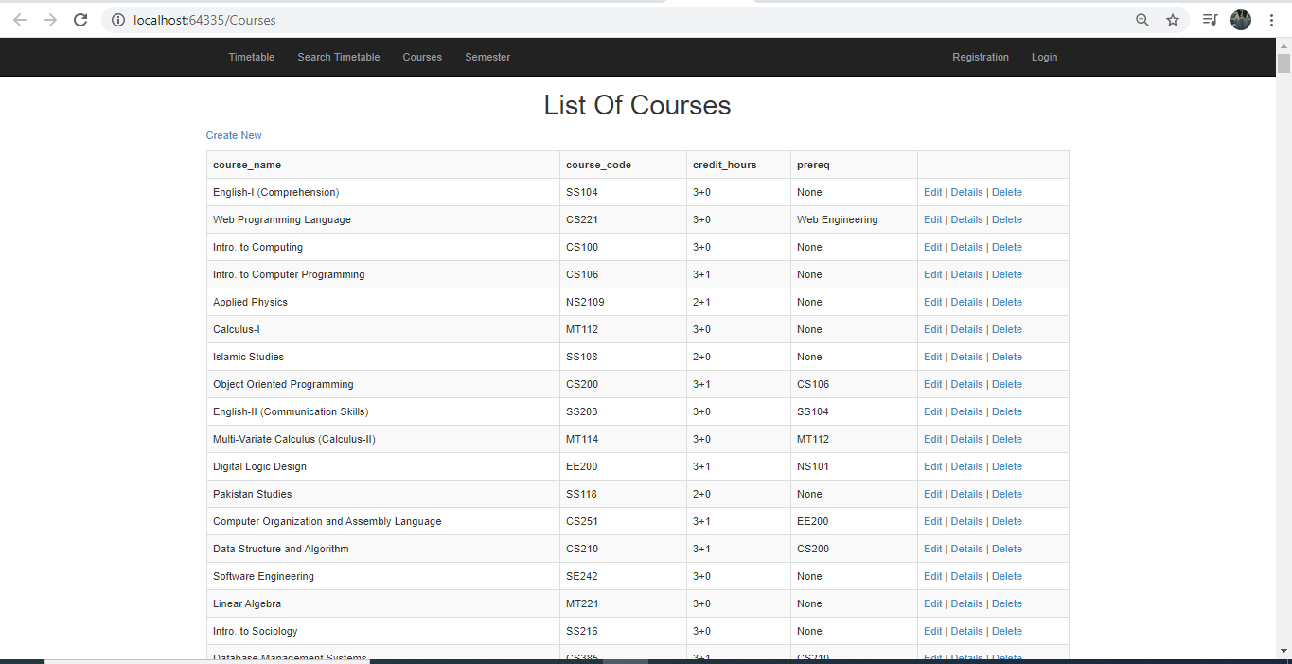

1. Timetable

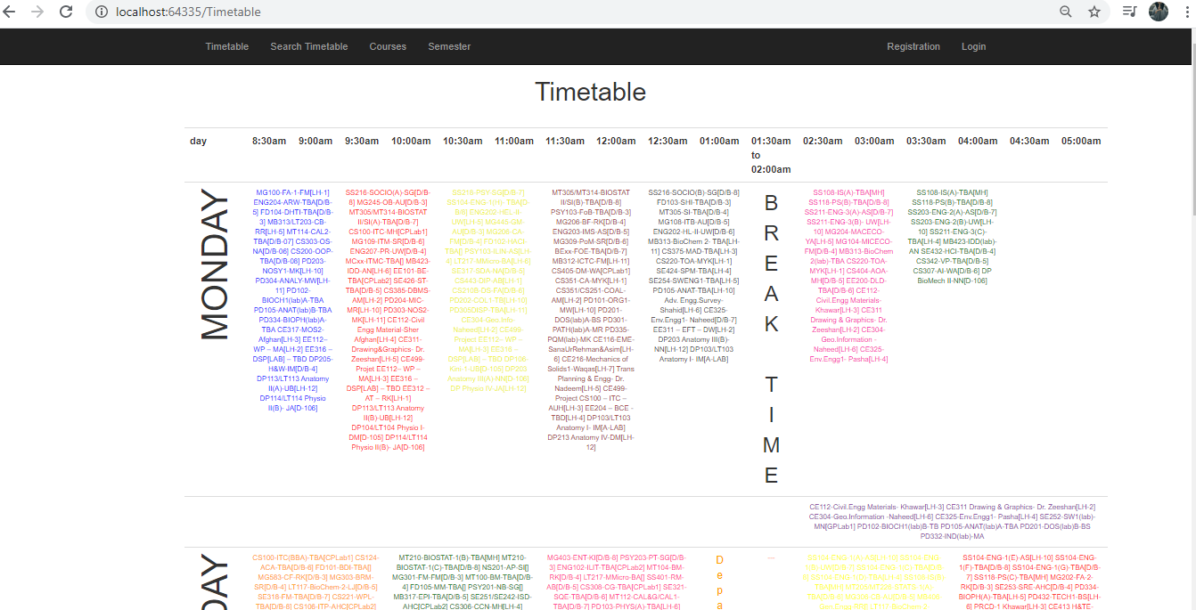

1. Search Timetable

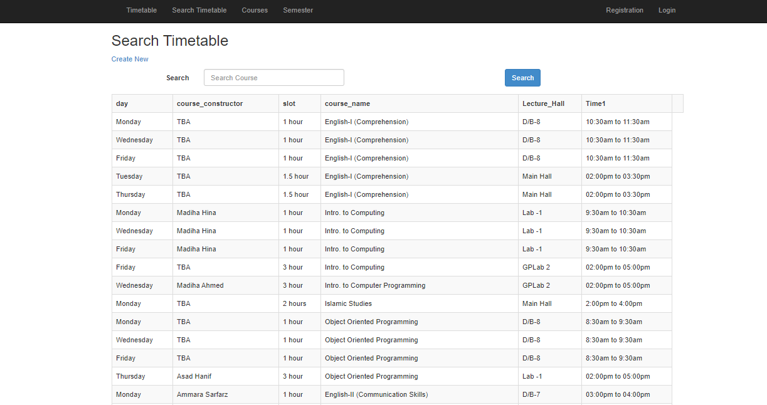

1. Semester Plain

Dash in some courses represent elective courses for student to select

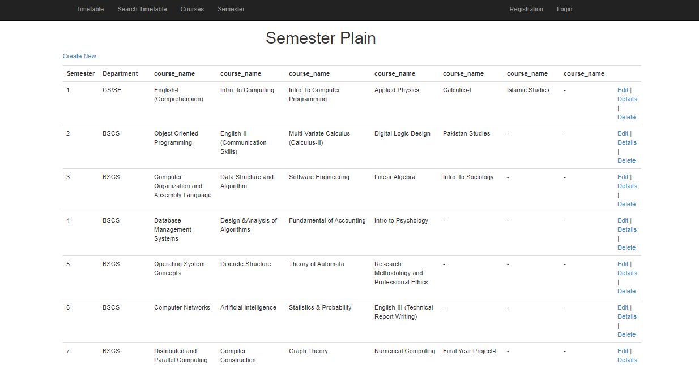

1. Registration

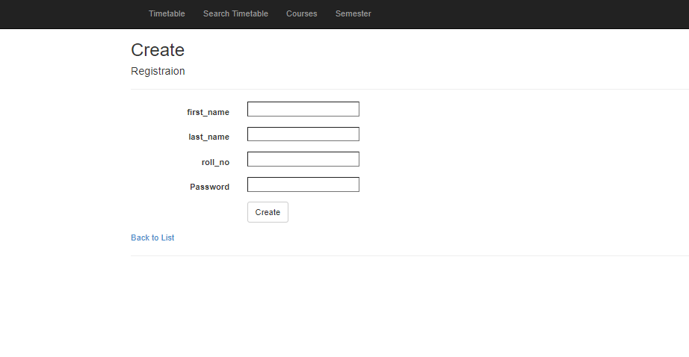



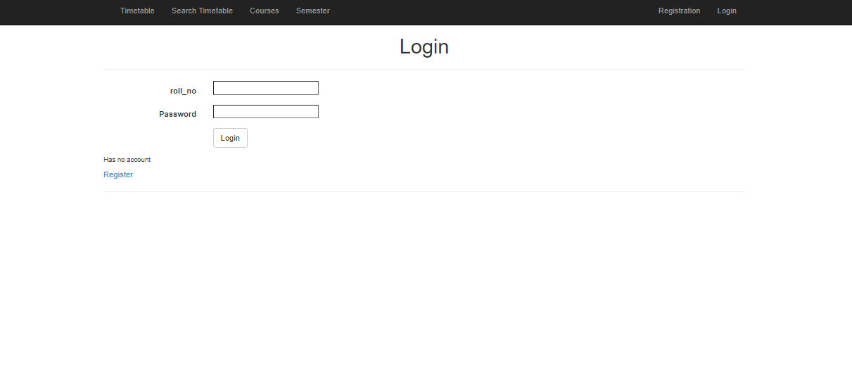

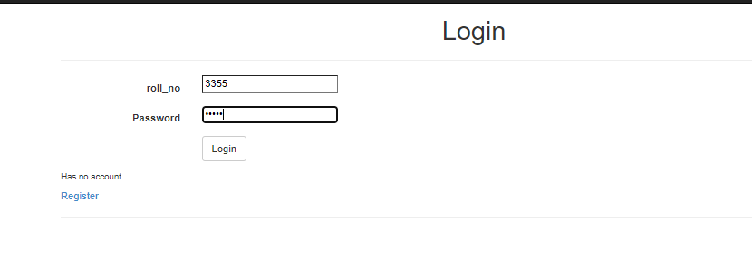

Error for incorrect data

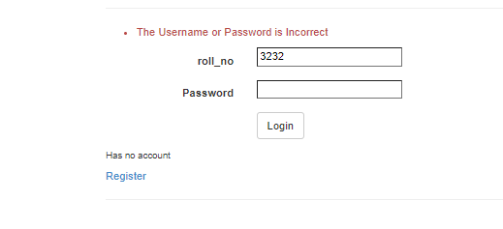

After Successful Login redirect to timetable

